Monday, May 26, 2015
Police Vulnerable Sector Check (PVSC) and Police Information Check (PIC) Protocol

The West London Minor Hockey Association requires that all individuals having contact with our players as rostered officials AND/OR being involved with team funds must have a current Police Record Check on file with our organization. Those having direct involvement with the players (Head Coach, Assistant Coaches, Trainer, Assistant Trainer, Manager or Assistant Manager) must complete the Police Vulnerable Sector Check. Managers or Treasurers not in direct contact with players must complete the Police Information Check.

NOTE: Approved rosters will not be released to teams until all volunteers have either:

- Signed the declaration if they had completed a Police Check last year
- Applied for a Police check and sent confirmation receipt to Risk management Director
- Provided Risk Management Director with an original approved Police Check (with police seal)

If a rostered or non-rostered volunteer has not provided at least the declaration (year 2 of active police check) or confirmation that an application has been submitted to the police by November 30, 2015, they will be removed from the Team Roster and Roster will be approved with remaining officials. Estimated turnaround time is 4 weeks.

These Police Checks may be valid for a period up to two years. However, the WLMHA reserves the right to ask any individual rostered on a team to submit to a Police Check and any subsequent fingerprinting at anytime. These checks may be requested with just cause or on a purely random basis.

Following are the steps required for obtaining Police Vulnerable Sector Check (PVSC) or Police Information Check (PIC) for WLMHA.

- Verify with the Risk Management Director if you are required to complete a Police Check for the current season. This can be done through the team coach by checking the list of active or “On File” individuals that the Risk Management Director has made available to the Competitive Director and/or Houseleague Director and, in turn, forwarded to the team head coaches. Any new team officials or individuals returning after a year away from a team should expect to complete a Police Check for that year.

- Police checks are required for all rostered team officials (i.e., Coach, Assistant Coach, Trainer, Assistant Trainer, Manager) and the following non-rostered team officials: Manager and Treasurer.

- Volunteers who completed and submitted their Police Checks (PVSC or PIC) during the 2014-2015 season will be required to sign a declaration confirming they have not been charged or convicted of a criminal offence since the date their last Police Check was approved. A copy of this declaration (including the date of your last check) will be provided by the Risk Management Director.

- Volunteers who completed a Police Information Check (PIC) last year and are now assuming a rostered volunteer role (Coach, Trainer, Manager, etc.) will need to complete the Police Vulnerable Sector Check (PVSC) this year.

- If you are required to complete a Police Check this season, login and register with the London Police Service's Online Police Background Check system. Site can be accessed at:

https://www.policesolutions.ca/checks/services/london/login.php

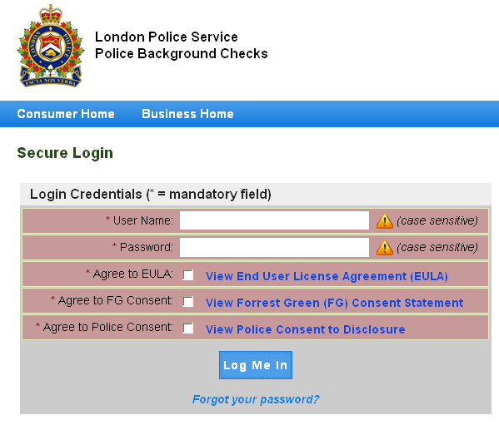

- Complete the on-line application for Police Vulnerable Sector Check (PVSC) or Police Information Check (PIC) for Employment or Volunteer Purposes. You can track the status of your request on the home screen:

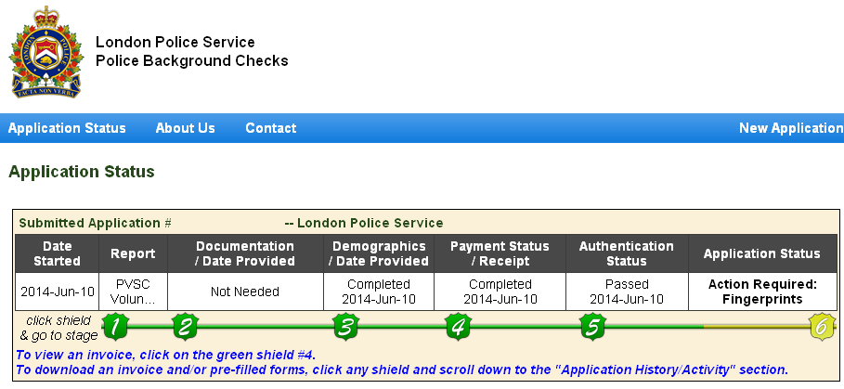

- Cost of the check is $15.00 plus HST ($16.29) and is the responsibility of the applicant.

- If Finger Printing is required, obtain a “Volunteer Letter” from Risk Management Director of WLMHA stating that you are indeed volunteering for our organization. Proceed to the London Police Reporting Centre at 1001 Brydges Street, London, to have your prints taken. Fingerprinting hours are Monday-Friday, 08:30am to 7:30pm. There is no additional charge for finger prints.

- Completed Police Check will be available for pick up at Police Headquarters or mailed to your home address. Please place the original in the Risk Management mail slot at the back of Kinsmen arena.

- Approved Police Checks are required by January 31, 2016 or you will be suspended from team functions until the form is provided.

- Head Coach or Team Manager will provide the Registrar, Competitive Director/House League Director and Risk Management Chair a list of the team’s rostered and non-rostered officials using the Team Set Up List found here:

http://westlondonhockey.ca/Libraries/1785/Team_Support_Documents/

.

Regards,
Dave Leff
President
WLMHA

